Sample Document - Full title (80 characters)
Author Name, Affiliation, Email ID

Abstract (up to 250 words)

This is a sample input file. Comparing it with the output it generates can show you how to produce a simple document of your own.
Keywords. Datacenter design, energy efficiency of datacenter, energy efficient metrics, datacenter carbon footprint computation.
Lisyt of Notations and Abbreviations

Introduction
Energy efficiency and low carbon strategies have attracted a lot of concern. The goal for 20% energy efficiency and carbon reduction by 2020 drove the Information Communication Technologies (ICT) sector to strategies that incorporate modern designs for a low carbon and sustainable growth [1, 2]. The ICT sector is part of the 2020 goal and participates in three different ways. In the direct way, ICT are called to reduce their own energy demands (green networks, green IT), in the indirect way ICT are used for carbon displacements and in the systematic way ICT collaborate with other sectors of the economy to provide energy efficiency (smartgrids, smart buildings, intelligent transportations systems, etc…). ICT and in particular data centers have a strong impact to the global CO₂ emissions. Moreover, an important part of the OPEX is due to the electricity demands. This paper presents the sources and challenges that have to be addressed to reduce carbon emissions and electricity expenses of the sector.
demands without considering the data volume. Taking into consideration this ratio, green IT technologies have important benefits in terms of:
- Reduce electricity costs and OPEX;
- Improve corporate image;
- Provide sustainability;
- Extend useful life of hardware;
- Reduce IT maintenance activities;
- Reduce carbon emissions and prevent climate change;
- Provide foundations for the penetration of renewable energy sources in IT systems.

Main Text

Data Center Infrastructure and Power Consumption

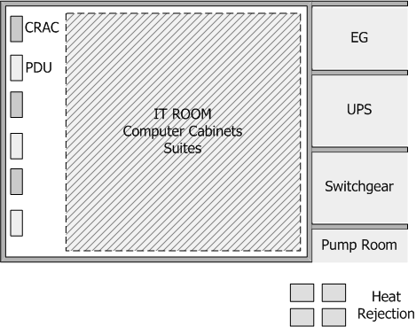
Figure 2.1. Typical Data Center Infrastructure [18, 19]
The overall design of a data center can be classified in 4 categories Tier I-IV each one presenting advantages and disadvantages related to power consumption and availability [18, 19]. In most cases availability and safety issues yield to redundant N+1, N+2 or 2N data center designs and this has a serious effect on power consumption. According to Figure 2.1, a data center has the following main units

Power Consumption in Data Centers
The equation should be submitted in the equation editor and should be keyed in as below in editable text:
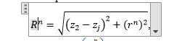 (2.1)
The optimal description of this value depends on the system’s characteristics and the type of equipment. As an example, for modulation and coding techniques in wireless communications the spectral efficiency is a common measure. For electronic components the ratio of joule per bit best describes performance. In telecommunication networks and datacenters the ratio of watts consumed over the Gbps of data processed is preferred. In [22] an absolute energy efficiency metric is introduced, named as dBε.

Conclusion
A concise summary of the findings and a clear identification of the advance/contribution that this work provides to the field.

Acknowlegdements

Figures and Tables Caption List

References

[1] International Telecommunication Union (ITU), report on Climate Change, Oct. 2008.
[2] G. Koutitas, P. Demestichas, ‘A review of energy efficiency in telecommunication networks’, Proc. In Telecomm. Forum (TELFOR), pp. 1-4, Serbia, Nov., 2009.
[3] Gartner Report, Financial Times, 2007.
[4] I. Cerutti, L. Valcarenghi, P. Castoldi, ‘Designing power-efficient WDM ring networks’, ICST Int. Conf. on Networks for Grid Applic., Athens, 2009.
[5] W. Vereecken, et. al., ‘Energy Efficiency in thin client solutions’, ICST Int. Conf. on Networks for Grid Applic., Athens, 2009.
[6] J. Haas, T. Pierce, E. Schutter, ‘Datacenter design guide’, whitepaper, the greengrid, 2009.
[7] Intel, ‘Turning challenges into opportunities in the data center’, White Paper,

